Supplier table created:

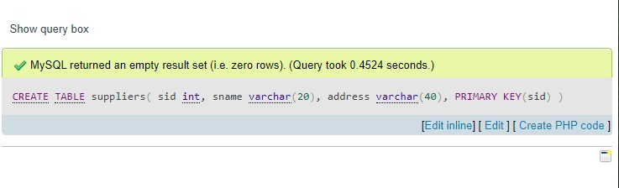

Parts table created:

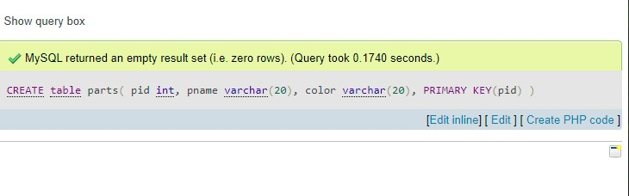

Catalog table created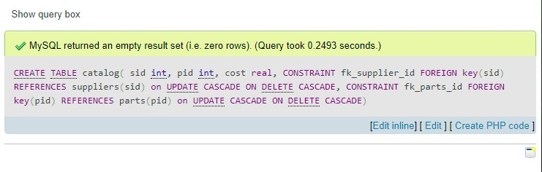

OUTPUT:

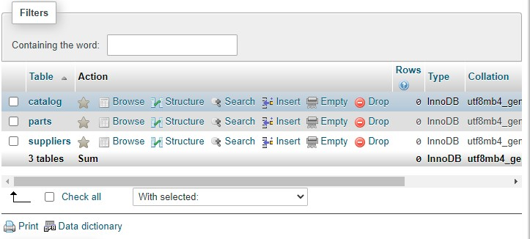

|  |  |  |
| --- | --- | --- |
| 1 | screws | black |
|  | [Edit Edit](http://localhost/phpmyadmin/tbl_change.php) | [Copy Copy](http://localhost/phpmyadmin/tbl_change.php) | [Delete Delete](http://localhost/phpmyadmin/sql.php) | 2 | compressors | red |
|  | [Edit Edit](http://localhost/phpmyadmin/tbl_change.php) | [Copy Copy](http://localhost/phpmyadmin/tbl_change.php) | [Delete Delete](http://localhost/phpmyadmin/sql.php) | 3 | brake pad | gray |
|  | [Edit Edit](http://localhost/phpmyadmin/tbl_change.php) | [Copy Copy](http://localhost/phpmyadmin/tbl_change.php) | [Delete Delete](http://localhost/phpmyadmin/sql.php) | 4 | wheel rims | blue |
|  | [Edit Edit](http://localhost/phpmyadmin/tbl_change.php) | [Copy Copy](http://localhost/phpmyadmin/tbl_change.php) | [Delete Delete](http://localhost/phpmyadmin/sql.php) | 5 | wheel rims | red |
|  | [Edit Edit](http://localhost/phpmyadmin/tbl_change.php) | [Copy Copy](http://localhost/phpmyadmin/tbl_change.php) | [Delete Delete](http://localhost/phpmyadmin/sql.php) | 6 | wheel rims | black |
|  | [Edit Edit](http://localhost/phpmyadmin/tbl_change.php) | [Copy Copy](http://localhost/phpmyadmin/tbl_change.php) | [Delete Delete](http://localhost/phpmyadmin/sql.php) | 7 | bonnet | black |
|  | [Edit Edit](http://localhost/phpmyadmin/tbl_change.php) | [Copy Copy](http://localhost/phpmyadmin/tbl_change.php) | [Delete Delete](http://localhost/phpmyadmin/sql.php) | 8 | brake lights | red |
|  | [Edit Edit](http://localhost/phpmyadmin/tbl_change.php) | [Copy Copy](http://localhost/phpmyadmin/tbl_change.php) | [Delete Delete](http://localhost/phpmyadmin/sql.php) | 9 | headlights | silver |
|  | [Edit Edit](http://localhost/phpmyadmin/tbl_change.php) | [Copy Copy](http://localhost/phpmyadmin/tbl_change.php) | [Delete Delete](http://localhost/phpmyadmin/sql.php) | 10 | outer frame | blue |
|  | [Edit Edit](http://localhost/phpmyadmin/tbl_change.php) | [Copy Copy](http://localhost/phpmyadmin/tbl_change.php) | [Delete Delete](http://localhost/phpmyadmin/sql.php) | 11 | outer frame | red |
|  | [Edit Edit](http://localhost/phpmyadmin/tbl_change.php) | [Copy Copy](http://localhost/phpmyadmin/tbl_change.php) | [Delete Delete](http://localhost/phpmyadmin/sql.php) | 12 | outer frame | black |